POWER BI & SQL UNIT TESTING

Emission Analysis :

Case 1 :
Card 1 : CO2 Emission YTD

Power BI :



Sql server :

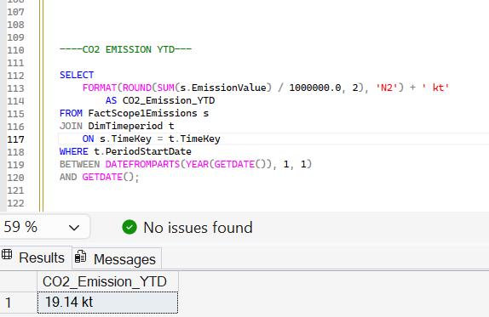

Card 2 : CO2 Emission PYTD

Power BI :



Sql server :

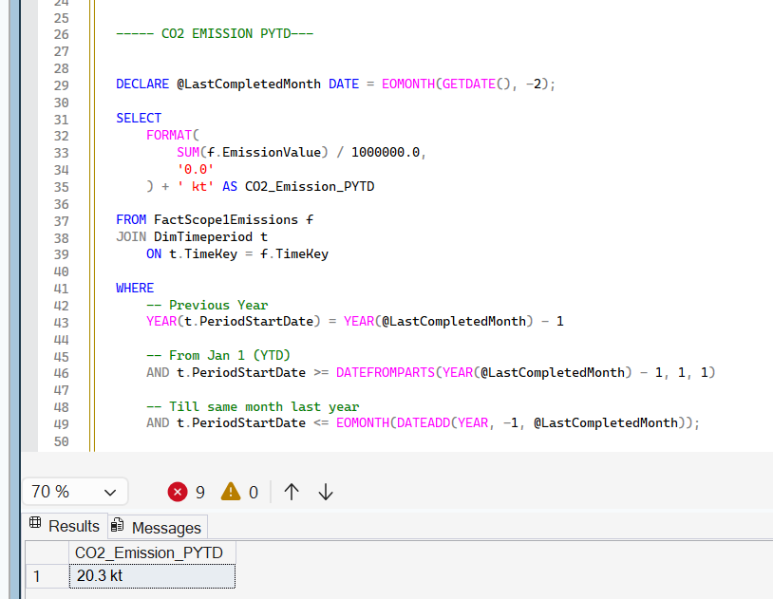

Card 3 : CO2 Emission QTD

Power BI :


Sql server :

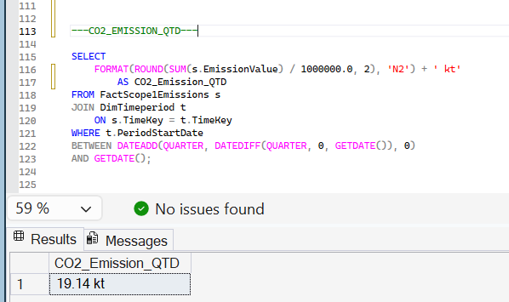

Card 4 : CO2 Emission MTD
Power BI :


Sql server :

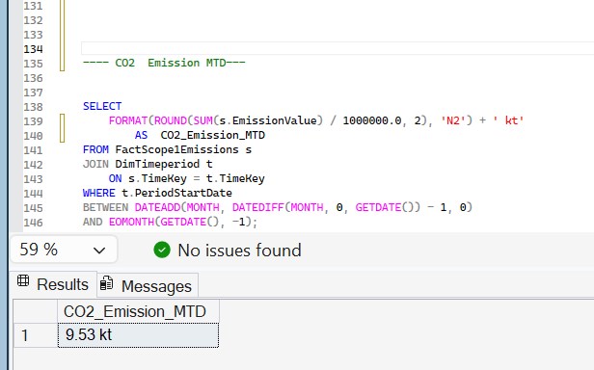
Case 2

Insights : CO2 Emission by Year, Quarter ,Month

CO2 Emission (2023)

Power BI :

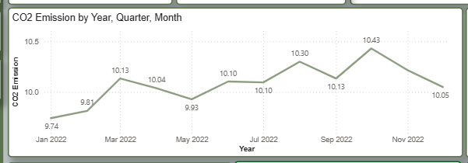
Sql server :

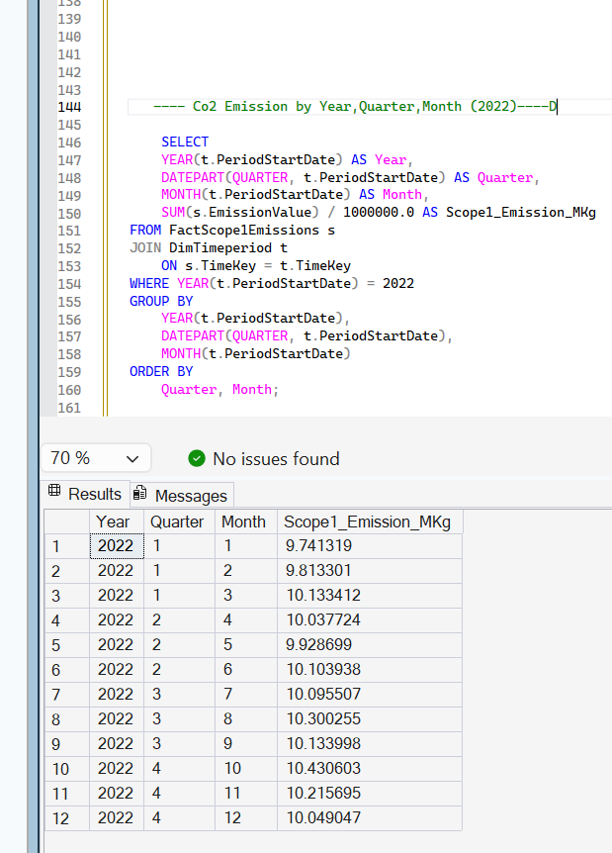

CO2 Emission (2023)

Power BI :

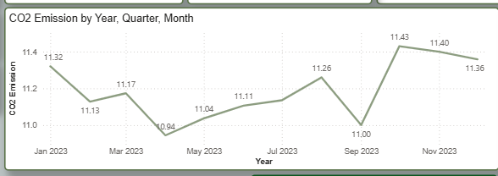
Sql server :

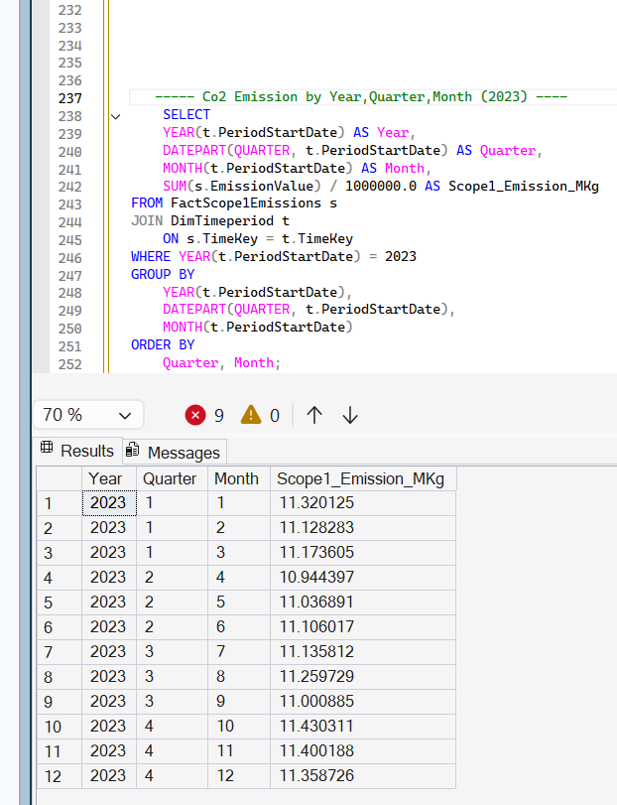
CO2 Emission (2024)

Power BI :
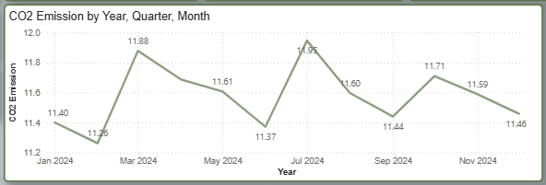
Sql server :

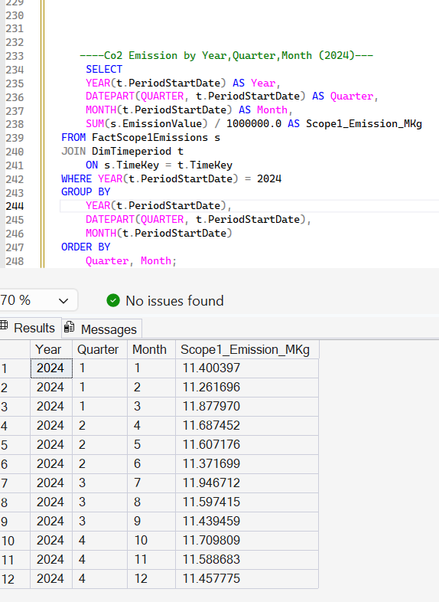

CO2 Emission (2025)

Power BI :

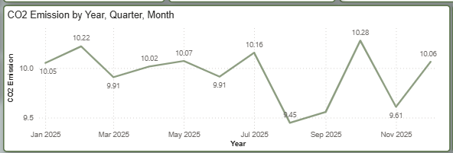

Sql server :

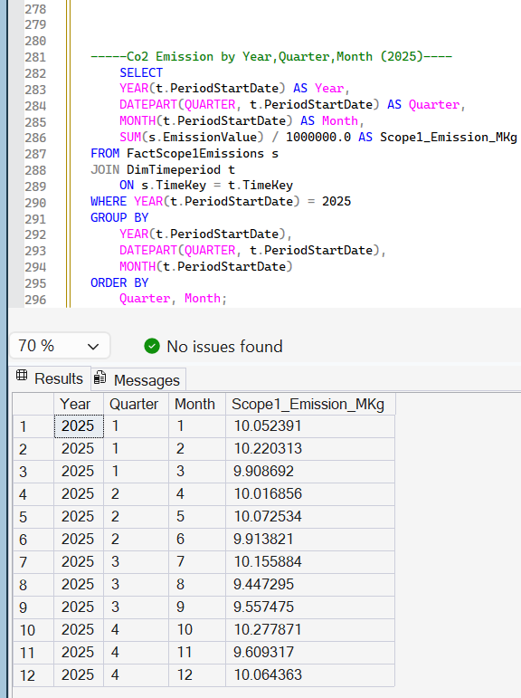

CO2 Emission (2026)

Power BI :

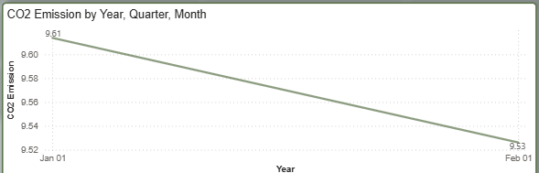

Sql server :

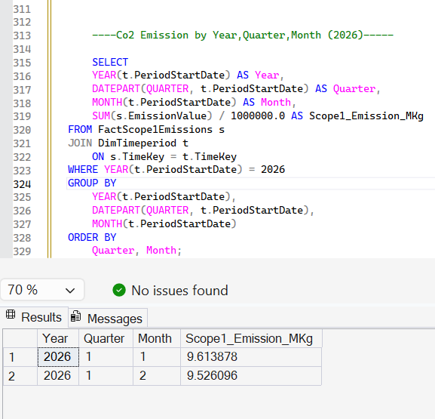

Case 3

Insights : CO2 Emission by Facility Type

Power BI :

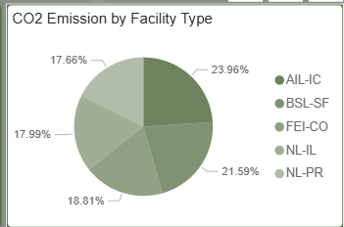

Sql server :

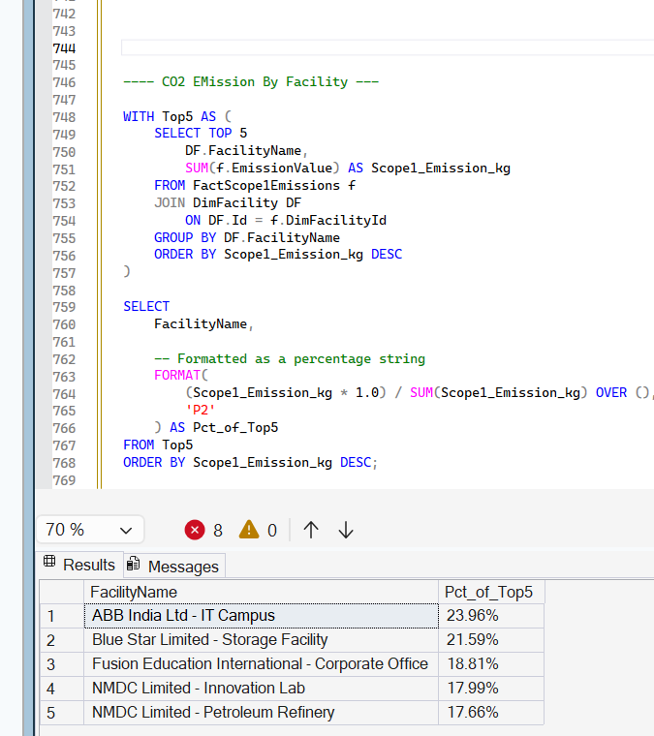
Case 4
Insights : CO2 Emission by Year

Power BI :

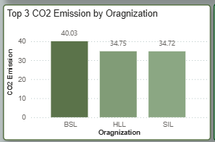
Sql server :

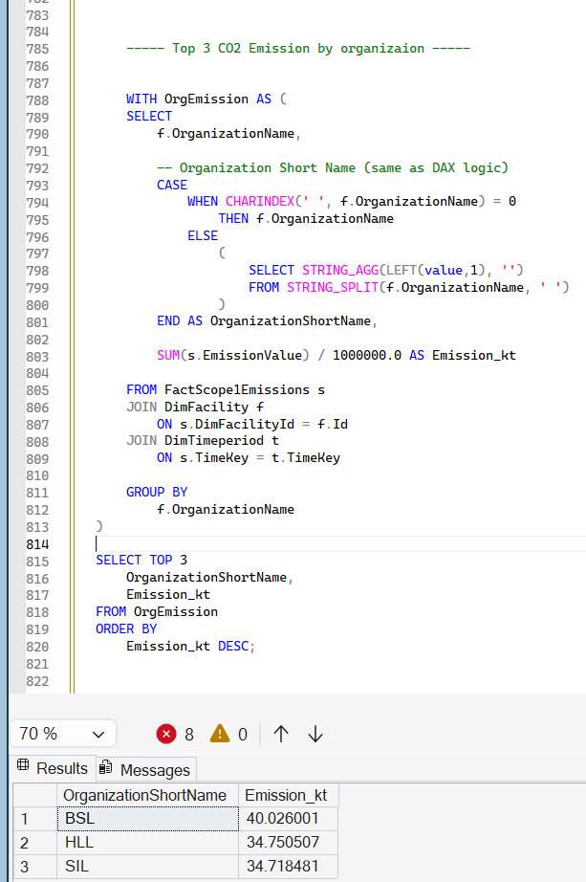
Case 5
Insights :Top 5 CO2 Emission by location

Power BI :
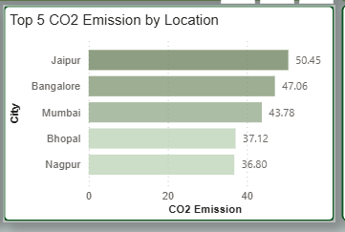

Sql server :

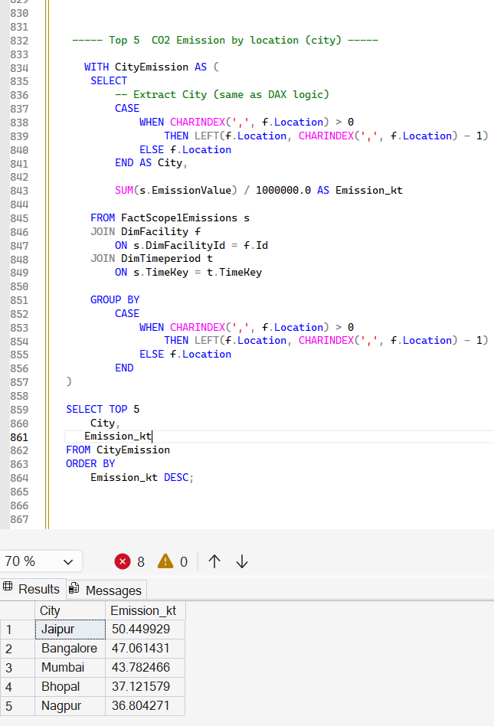
Case 6
Insights : Top 5 CO2 Emission by fuel Type

Power BI :

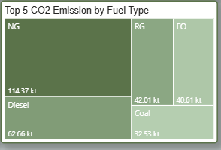

Sql server :



